Phase 3 **Data Modeling & Relationships**

Create Custom Object : Price_Rule__c

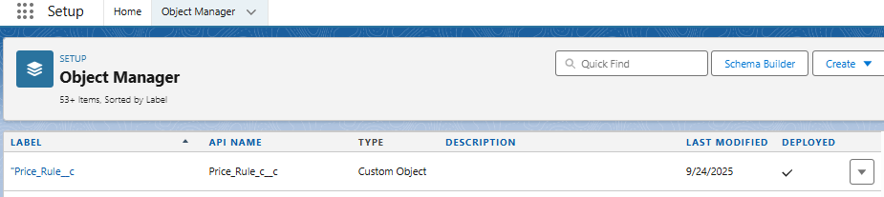

**Add Fields to Quote**

• Go to **Setup > Object Manager > Quote**.

• Select **Fields & Relationships** > **New**.

• **Customer_Segment__c**

* Data Type: Picklist (values: e.g., Enterprise, SMB, Public Sector, etc.)

• **Einstein_Score__c**

* Data Type: Number (length 3, decimal places 2 if you want scores like 95.50).

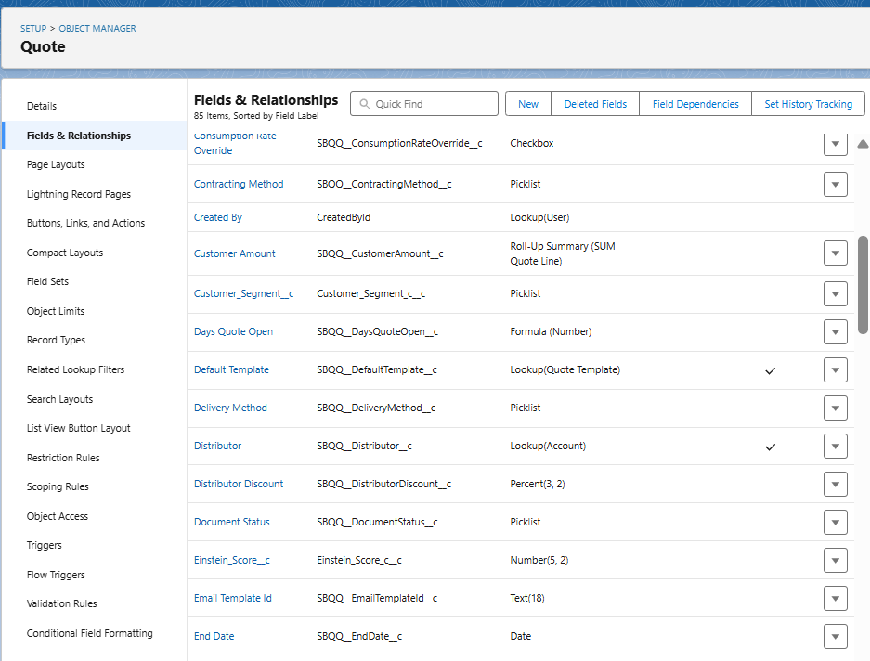

**Design Page Layouts**

In **Quote > Page Layouts**, click **Edit** on the main 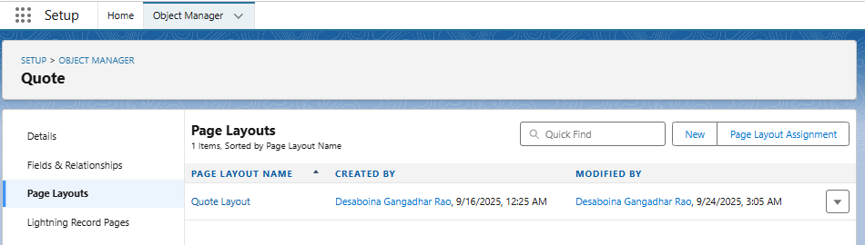layout.

**Use Schema Builder**

• Go to **Setup > Schema Builder**.

• On the left, select **Price_Rule__c, Quote, Quote Line, Opportunity, Product2**.

• Drag them into the canvas.

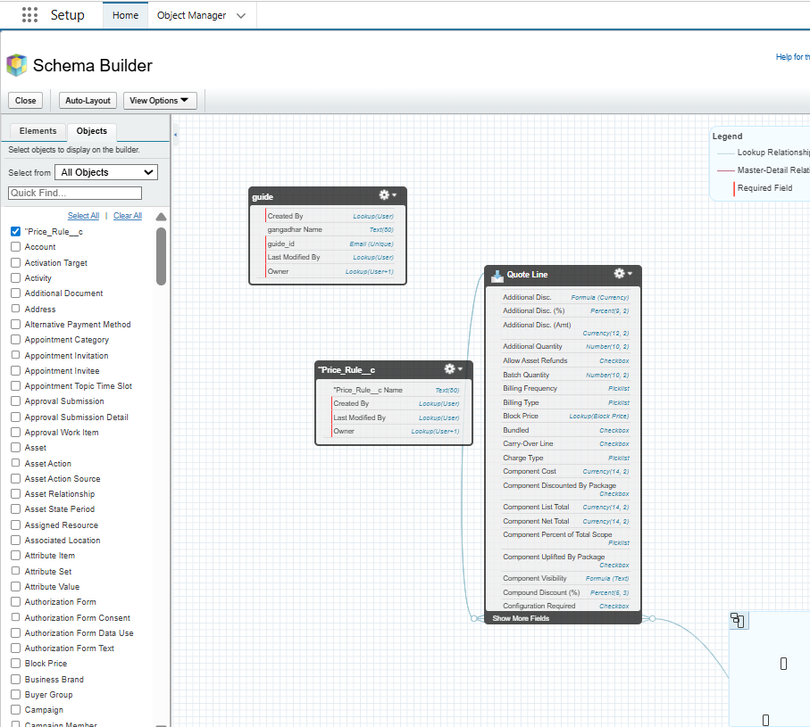

**Testing**

